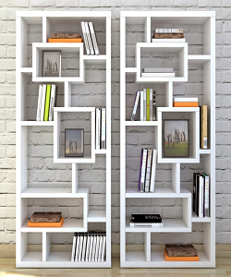

Universal Modern Bookcase

$98.67

Availability: In stock

**Description:**

The real modular extruded wood bookcase, a special way to personalize your space. It’s a system that can be used everywhere: in office, in living room, and in a book store of a winebar.This furniture is usable for every need.